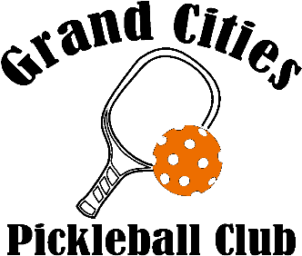
Membership Application
January 1 – December 31
Annual Membership Dues:
Individual -- $30, Household -- $50

Please check Membership that applies:
New Membership Individual Membership -- $30
Renewal Membership Household Membership -- $50

First & Last Name: | Phone:
Address: | Email:

For Household, please list full name, phone, & email of each player:
Name: | Phone: | Email:
Name: | Phone: | Email:
Name: | Phone: | Email:
Household is defined as a maximum of 2 parents with their children/dependents (up to age 26) living in the same household or who are qualified students. If any players of the household are under the age of 18, they must be accompanied by an adult of the same household in order to play during any given session.

Thank you for your membership! Membership dues allow Grand Cities Pickleball Club to grow and supply members with good quality equipment. Thank you for your support!

Club’s Mission Statement: To be a cornerstone for pickleball players’ success
by providing structure, instruction, and community camaraderie.

Payment Options: Online by credit card or Venmo Personal Check Cash
Make checks payable to Grand Cities Pickleball Club. Thank you!
Mail to Treasurer: Kim Reardon, Treasurer, 403 Mero Court SE, East Grand Forks, MN 56721

www.grandcitiespickleball.com
Follow us on Facebook! Join us on What’s App!

